03. Tree

- Introduction

A tree has the following features.
- A tree is a collection of n nodes and n – 1 edges. One of the nodes is the root.
- In a tree, there is exactly one path from the root to each node.
- For any node v, the depth (or level) of v is the length of the path from the root to v. The root is at depth 0.
- A leave is a node that has no children.
- For any node v, the height of v is the longest path from v to a leaf. All leaves are at height 0.

The following shows the data structure of a tree node.

struct TreeNode
{
int element;
TreeNode *first_child;
TreeNode *next_sibling;
}

- Binary Tree

A binary tree is a tree in which each node has at most two children, which are referred to the left child and the right child. The following shows the data structure of a binary tree node.

struct BinaryNode
{
int element;
BinaryNode *left;
BinaryNode *right;
}

You can use binary tree to construct an expression tree from a postorder expression. Read one symbol at a time.
- If the symbol is an operand, we create a one-node tree and push a pointer to it onto a stack.
- If the symbol is an operator, pop two pointers to two trees T1 and T2 from the stack and form a new tree whose root is the operator and whose left and right children point to T2 and T1, respectively. A pointer to this new tree is then pushed onto the stack.

- Binary Search Tree

In a binary search tree, for every node v, the values of all the nodes in the left subtree are smaller than the value of v, and the values of all the nodes in the right subtree are larger than the value of v.
- This implies that all the elements in a binary search tree are ordered. The smallest element is the one on the leftmost side. The largest element is the one on the rightmost side.
- Duplicates are handled by keeping an extra field in the node record indicating the frequency of occurrence.
- The time complexity of searching a node in a binary search tree is O(log n).

Traversal

There are three ways to process the nodes of a tree.
- In a preorder traversal, the processing order is: node -> left child -> right child.
- In a postorder traversal, the processing order is: left child -> right child -> node.
- In an inorder traversal, the processing order is: left child -> node -> right child.

The following shows the inorder traversal.

void process(BinaryNode *n)
{
if (n != NULL)
{
process(n->left);
out << n->element << endl;
process(n->right);
}
}

Insertion

In an insertion operation, the new element is always added as a leaf.

void insert(int x, BinaryNode *&n)
{
if (n == NULL)
{
n = new BinaryNode(x);
}
else if (x < n->element)
{
insert(x, n->left);
}
else if (x > n->element)
{
insert(x, n->right);
}
else
; // duplicate, do nothing
}

Deletion:
- If the node v is a leaf, easiest.
- If the node v has one child, easier.
- If the node v has two children, the general strategy is to find the node u with the smallest key under the right subtree, replace the key of node v with the key of node u and then delete the node u. You can also find the node x with the largest key under the left subtree, replace the key of node v with the key of node x and then delete the node x. To avoid the deletion making one subtree (left or right) deeper than the other, you can randomly choose between the right subtree and the left subtree when replacing the element to be deleted.

Example:
void delete(BinaryNode *&node, int x)
{
if (node == NULL)
{
return;
}

if (x < node->element)
{
delete(node->left, x);
}
else if (x > node->element)
{
delete(node->right, x);
}
else
{
if (node->left == NULL)
{
BinaryNode *temp = node;
node = node->right;
delete temp;
}
else if (node->right == NULL)
{
BinaryNode *temp = node;
node = node->left;
delete temp;
}
else
{
BinaryNode *temp = findMin(node->right);
node->element = temp->element;
delete(node->right, temp->element);
}
}
}

The following shows the contains, findMin, and findMax implementations.

bool contains(int x, BinaryNode *n)
{
if (n == NULL)
return false;

if (x == n->element)
return true;

if (x < n->element)
return contains(x, n->left);
else
return contains(x, n->right);
}

BinaryNode *findMin(BinaryNode *n) // recursive
{
if (n == NULL)
return NULL;

if (n->left == NULL)
return n;

return findMin(n->left);
}

BinaryNode *findMax(BinaryNode *n) // non-recursive
{
if (n == NULL)
return NULL;

while (n->right != NULL)
{
n = n->right;
}

return n;
}

- AVL Tree

An AVL tree is a self-balancing binary search tree in which the heights of the left and right subtrees of each node differ by at most 1. A new height field is added to the data structure.

struct AVLNode
{
int element;
int height;
AVLNode *left;
AVLNode *right;
}

When an insertion is done, you need to update the height of the nodes on the path back to the root. If any node whose new balance violates the AVL condition, you need to do a rotation based on the following four cases.

Single Left Rotation (LL)

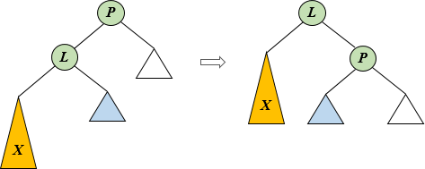

The following shows the implementation.

if (P->left->height – P->right->height == 2 && X->element < P->left->element)
{
P->left = L->right;
L->right = P;

P->height = MAX(P->left->height, P->right->height) + 1;
L->height = MAX(L->left->height, P->height) + 1;

// set P to the L node so that P's parent points to L now
P = L;
}

Single Right Rotation (RR)

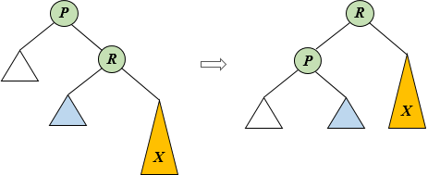

The following shows the implementation.

if (P->right->height – P->left->height == 2 && X->element > P->right->element)
{
P->right = R->left;
R->left = P;

P->height = MAX(P->left->height, P->right->height) + 1;
R->height = MAX(P->height, R->right->height) + 1;

P = R; // set P to the R node so that P's parent points to R now
}

Double Left Rotation (LR)

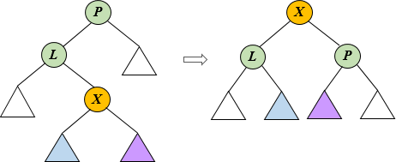

The following shows the implementation.

if (P->left->height – P->right->height == 2 && X->element > P->left->element)
{
RR(P->left);
LL(P);
}

Double Right Rotation (RL)

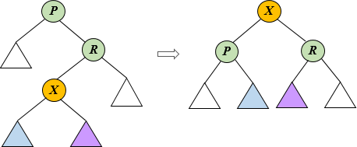

The following shows the implementation.
if (P->right->height – P->left->height == 2 && X->element < P->right->element)
{
LL(P->right);
RR(P);
}

- Splay Tree

The splay tree guarantees that any m consecutive operations take at most O(mlogn) time. The basic idea of the splay tree is that after a node is accessed, it is pushed to the root by a series of AVL tree rotations. This idea is based on the assumption that when a node is accessed, it is likely to be accessed again in the near future.

Splay tree is much simpler to program than AVL tree, since there are fewer cases to consider and no balance information to maintain. A new field, parent, is added to the data structure.

struct SplayNode
{
int element;
SplayNode *left;
SplayNode *right;
SplayNode *parent;
}

There are three cases of rotation.
- X has no grandparent (Zig). In this case, the parent of X is the root. We merely rotate X and the root. This is the last rotation along the access path. The following shows the case that X is the left child of the root.

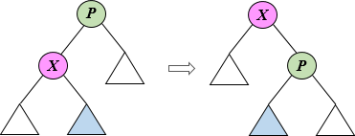

The following shows how to Right-Rotate the node P.

P = X->parent;
Xr = X->right;

X->right = P;
x->parent = p->parent;

P->left = Xr;
P->parent = X;

if (Xr != NULL)
{
Xr->parent = P;
}

if (X->parent != NULL)
{
if (X->parent->left == P)
{
X->parent->left = X;
}
else
{
X->parent->right = X;
}
}

- X is LR or RL grandchild (Zig-Zag). In this case, X has both a parent P and a grandparent G. X is a left child and P is a right child (or X is a right child and P is a left child). In this case, we just left rotate P and then right rotate G (or right rotate P and then left rotate G).

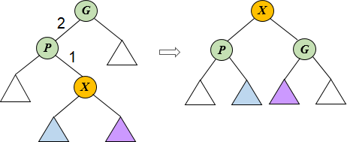

- X is LL or RR grandchild (Zig-Zig). In this case, X has both a parent P and a grandparent G. X and P are either both left children (LL) or both right children (RR). In this case, we need to right rotate G and then right rotate P (or left rotate G and then left rotate P).

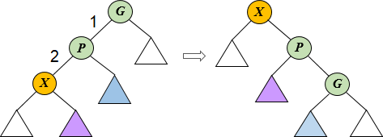

The following shows the operations.
- Find. First do an ordinary find operation. Once you find item X, perform a splay to move X to the root. If X is not found, perform a splay on the last node on the access path.
- Insert. First do an ordinary insert operation, then splay X to the root. If X was already in the tree, just splay on X.
- Delete. First do a FIND operation on X (after that, X would be the root). Then delete the root node which is X. Next, splay the largest element of the left subtree to the root, and attach the right subtree to the root. You can also splay the smallest element of the right subtree to the root, and attach the left subtree to the root.

- B-Tree

A B-tree of order m is a tree with the following structural properties:
- The root has 0 or 2 ~ m children.
- The internal nodes have (m/2) ~ m children.
- All leaves are at the same depth.

All the data items are stored at leaves. Each non-leaf node contains m pointers and m-1 values, in which each pointer points to a child, and each value represents the smallest key in the data leaves to which the pointer points. The following shows a B-tree of order 3.

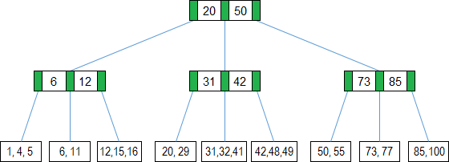

Insert

When a new key is inserted, if the leaf node is full, this node is split into two nodes. If the parent node is also full, it will keep on splitting nodes on the path to the root until an allowed position is found. In some case, the root may need to be split and a new root is yielded. In this case, the height of the tree is incremented by one.

In some insertion, if the last sibling is not full and the current node is full, the first key of the current node can be moved to the last sibling. The new key is inserted without splitting and so the space is saved. Of course, the value part of the parent node also need changed.

Delete

When an existed key is deleted, there are two cases may occur.
- If the total number of the keys on the current node not including the deleted key and the keys on the sibling node is less than m, the two nodes are combined into one.
- Otherwise, if the keys left on the node are less than m/2, a key on the sibling node is stolen and added to the current node.

In some case, the combination will be traced to the root, and so the height of the tree is decreased by one.

- Red-Black Tree

The red-black tree is an alternative to the AVL tree. The operations on red-black trees take O(logn) time in the worst case. A red-black tree is a self-balancing binary search tree with the following properties.
- Every node is colored either red or black.
- The root is black.
- If a node is red, its children must be black.
- Every path from a node to a NULL pointer must contain the same number of black nodes.

The following shows a red-black tree.

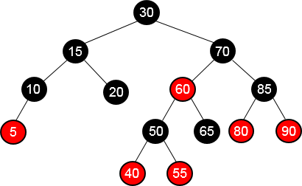

The following shows the data structure of the red-black tree.

struct RedBlackNode
{
int element;
RedBlackNode *left;
RedBlackNode *right;
RedBlackNode *parent;
int color;
}

Insert

When inserting a new item, it is always inserted as a leaf. Since the rule 4, the new item must be colored red.
- If the parent is black, then it is done.
- If the parent is red, we need to rotate the tree and change the color of the nodes.

Delete

When deleting a node, if the node has no children.
- If the node is red, we simply delete it.
- If the node is black, we delete it and rotate the tree to ensure the balancing.

If the node has only one child.
- If the node is red, we simply replace it with its child.
- If the node is black and its child is red, we simply replace it with its child and change its child to black.
- If both the node and its child are black. We need to rotate the tree and change the color of the nodes.

If the node has two children, we can find either the maximum element in its left subtree or the minimum element in its right subtree, move its value to the node being deleted, and then delete the node that we copied the value from. This node must have at most one child. We can follow the two cases above to delete it.

- Appendix

The following shows the code for a splay tree.

class splay_tree
{
struct Node
{
int key;
Node *left;
Node *right;
Node *parent;
};

Node *root;

// P->left = X
void right_rotate(Node *P)
{
Node *X = P->left;

if (X)
{
P->left = X->right;

if (X->right)
{
X->right->parent = P;
}

X->right = P;
X->parent = P->parent;
}

if (!P->parent)
{
root = X;
}
else if (P == P->parent->left)
{
P->parent->left = X;
}
else
{
P->parent->right = X;
}

P->parent = X;
}

// P->right = X
void left_rotate(Node *P)
{
Node *X = P->right;
if (X)
{
P->right = X->left;
if (X->left)
{
X->left->parent = P;
}

X->left = P;
X->parent = P->parent;
}

if (!P->parent)
{
root = X;
}
else if (P == P->parent->left)
{
P->parent->left = X;
}
else
{
P->parent->right = X;
}

P->parent = X;
}

void splay(node *X)
{
while (X->parent)
{
// X->parent is the root
if (!X->parent->parent)
{
if (X->parent->left == X) // X is left child
{
right_rotate(X->parent);
}
else
{
left_rotate(X->parent); // X is right child
}
}
// G->left = P and P->left = X
else if (X->parent->left == X && X->parent->parent->left == X->parent)
{
right_rotate(X->parent->parent);
right_rotate(X->parent);
}
// G->right = P and P->right = X
else if (X->parent->right == X && X->parent->parent->right == X->parent)
{
left_rotate(X->parent->parent);
left_rotate(X->parent);
}
// G->right = P and P->left = X
else if (X->parent->left == X && X->parent->parent->right == X->parent)
{
right_rotate(X->parent);
left_rotate(X->parent);
}
// G->left = P and P->right = X
else
{
left_rotate(X->parent);
right_rotate(X->parent);
}
}
}
}

